EXPERIMENT:1: Create a simple cloud software application for Flight Reservation System using any Cloud Service Provider to demonstrate SaaS include the necessary fields such as one way, round trip, From, to, Departure, Departure, Travelers & Class, Fare Type, International and Domestic Flights etc.

STEP:1:CREATE A APPLICATION FORM ON PASSENGER DETAILS.

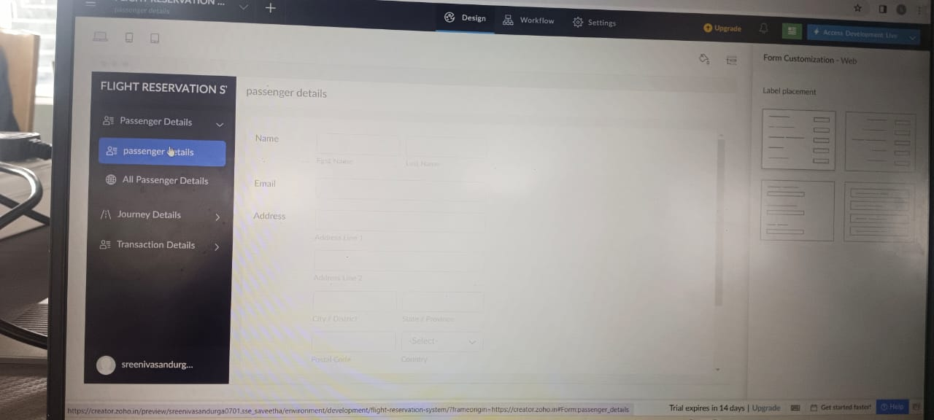

STEP:2 : CREATE A APPLICATION FORM FOR THE JOURNEY DETAILS.

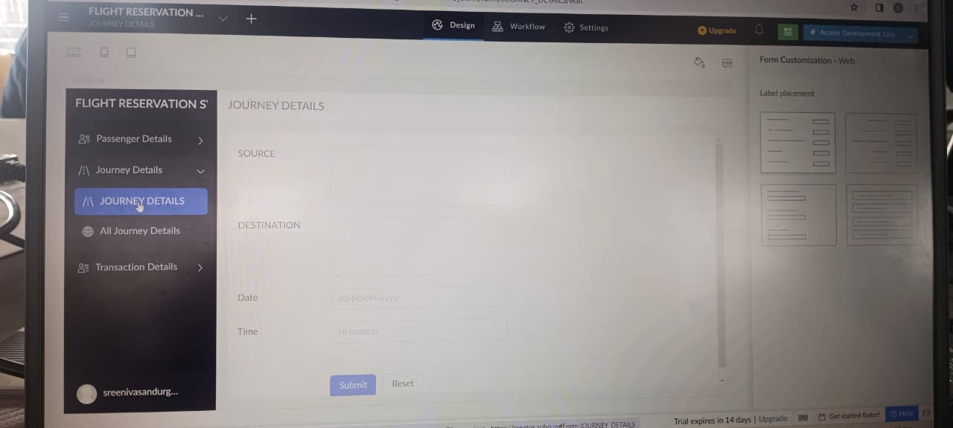

STEP:3:CREATE A APPLICATION FORM FOR THE TRANSACTIONS DETAILS.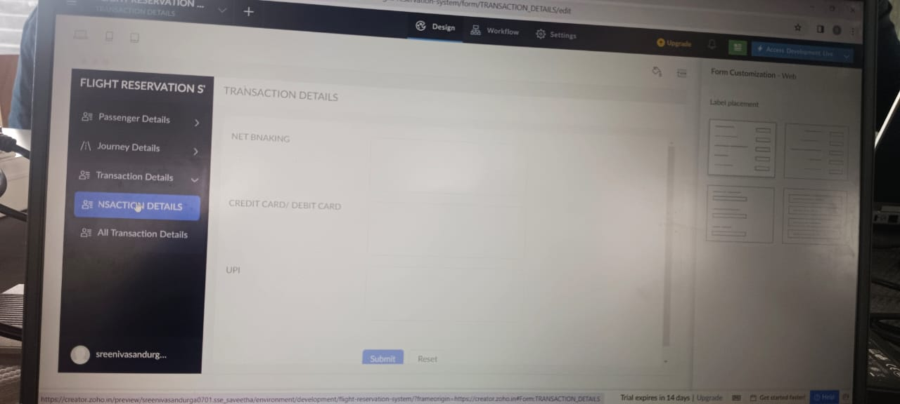

STEP:4: CREATE A APPLICATION FORM FOR THE FLIGHT RESULT:

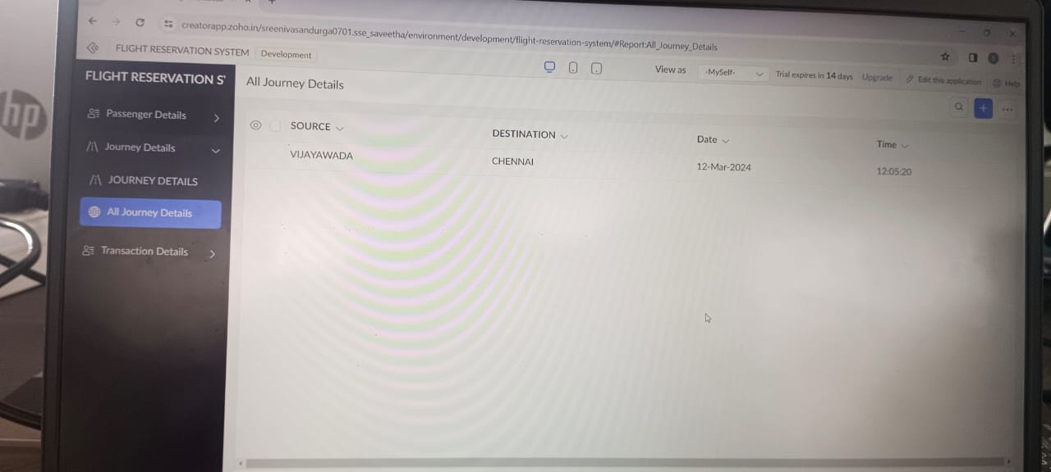

RESULT: THUS,THE PROGRAM FOR THE FLIGHT RESERVATION SYSTEM HAS BEEN DONE SUCCESSFULLY.